**Property Values**

Alek Kariniemi

Student, Arizona State University

ITA494 - City of Water

Serena Ferrando

May 1, 2024

In our class, titled "City of Water," each student was tasked with creating a map of Milan, focusing on any aspect related to water. During a brainstorming session by the whiteboard, classmates suggested various water related things to map, such as swimming pools, fire hydrants, and water fountains. Struggling with sickness that day, I found it hard to think of any ideas. Later, someone suggested mapping the economic disparities in different Milanese neighborhoods, this sparked my interest. We had learned in one of the previous lectures about the historical significance of the canals, they were initially clean and prosperous and later fell into neglect, becoming a place of poverty. Today, they have been restored and are now sought after locations, often featuring luxurious vacation homes. The differences in economic status interested me. I decided to map the relationship between property values and proximity to the canals. My goal was to create a visual representation showing that properties along the canals are more valuable compared to other areas in Milan.

Learning that properties along the canals were more expensive was something I and many others would have to take at face value. Verifying such claims alone would be a big challenge. One might consider using Google Maps to view individual houses by the canal and research their market values, but assessing the worth of each property individually across Milan is impractical due to the sheer volume. Recognizing the limitations of manual comparison, I realized that a visual representation would be the most efficient method to analyze and display this relationship. Coincidentally, creating a map would be the perfect way to illustrate the correlation between property values and their proximity to the canals. Mark Monmonier notes in *How to Lie With Maps*, an effective map must maintain simplicity (Monmonier, 2018, p. 1). Accordingly, my map would feature only a basic layout of Milan with overlaid property values. To make comparisons possible at a glance, I used a color gradient on the map, red indicating high value properties and green showing lower-value properties. This visual approach allowed for an instant understanding of the economic landscape relative to the canals.

Determined to visualize the property values effectively, I faced a critical decision regarding the choice of mapping software. Initially, Neatline was the default option, as it enabled collaborative contributions from all class members. However, Neatline required manual input for each data point, a time consuming method that did not suit my needs. Seeking a more efficient solution, I consulted my professor, who recommended QGIS for its capability to automate the data plotting process. This recommendation aligned perfectly with Anne Kellis Knowles’ perspective on Geographic Information Systems (GIS), which she describes as a tool that "emphasizes visualization and underscores the indispensable value of the visual by using maps to communicate results” (Knowles & Hillier, 2008 p. 63). Inspired by this insight, I chose QGIS to better illustrate the economic disparities along Milan’s canals.

While learning QGIS through an online tutorial, I discovered that I could import a CSV file to plot points on a map. Initially, I searched the internet hoping to find an existing CSV file with all of Milan's property data, which would save considerable time. However, after a few minutes, it became apparent that obtaining such a file for free was highly unlikely. Consequently, I decided to create the CSV file myself. Inspired by a concept from *Digital Humanities*, which highlights how programs can process information in the humanities, I wrote a Python script to automate the CSV creation (Burdick et. al, 2016, p. 17). This script was designed to quickly organize data into a format suitable for QGIS. The challenging part was not creating the CSV file but sourcing the data and developing a script to collect it efficiently. I found a real estate website, immobiliare.it, which provided the necessary property values, sizes, and locations. After compiling the data into the CSV, I imported it into QGIS. To visually differentiate the property values, I set the map points to display in varying shades of red and green, clearly indicating their economic value.

The completed map now visually represents the relationship between property values and the canals of Milan. However, contrary to expectations, it does not conclusively show that property values along the canals are higher. This discrepancy could stem from several factors. First, the dataset included only about 1,300 properties, which may not sufficiently represent the entire market. Secondly, the map only featured properties currently listed for sale, omitting those not on the market, which could skew the results. Additionally, the inclusion of condos, whose values might disproportionately influence the data due to size variations, could have distorted the findings. For future improvements, I would refine the data collection process to include rental properties and those not listed for sale, ensuring a more comprehensive dataset. Enhancing the visibility of the canals on the map would also help clarify their relationship to property values, making the intended analysis more apparent to viewers.

Link to GitHub: <https://github.com/Pakar040/property-values-in-milan-italy>

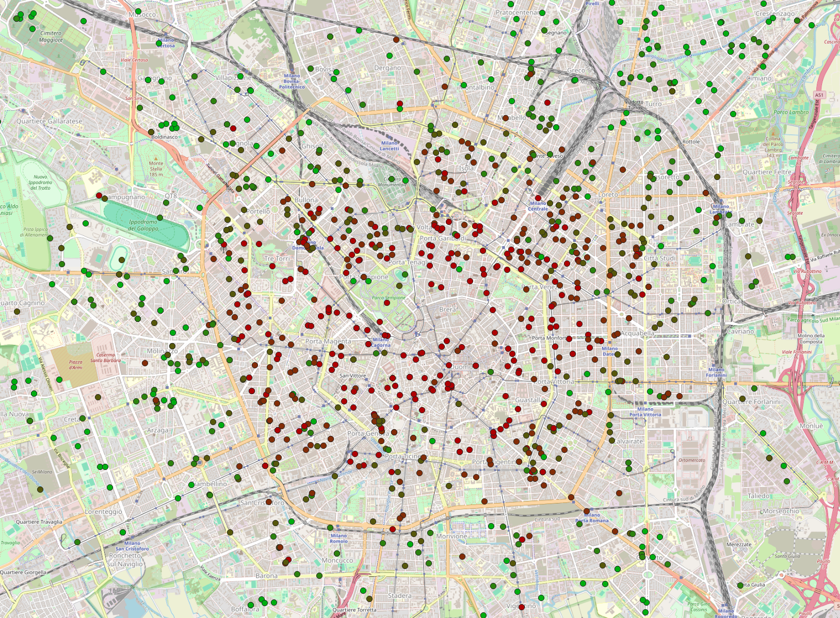

**References**

Monmonier, M. S. (2018). *How to lie with maps*. The University of Chicago Press.

Knowles, A. K., & Hillier, A. (2008). *Placing history: How maps, Spatial Data, and GIS are changing historical scholarship*. ESRI Press.

Burdick, A., Drucker, J., Lunenfeld, P., Presner, T. S., & Schnapp, J. T. (2016). *Digital-Humanities*. The MIT Press.